**RGB LED Circular control**

If the programmable RGB lamp is fully lit, the battery is not enough voltage, it will affect the effect,such as color saturation of RGB lamp is reduced.

It is recommended to use the USB data cable to plug in the RGB LED Circular expansion board interface. As shown in the figure below.

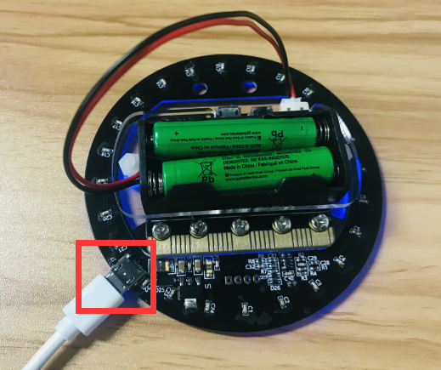

**Experimental phenomena:**

After the power is turned on, the first light is blue. When the A key is pressed, a random color light will light up and circle on the RGB LED Circular. Press the A key again, the light of a random color will be lit again and the circle will be rotated. When you press the B key to turn off all lights.

Please see the mp4 video file for details.